Digital Civility Index (DCI) – International

Microsoft conducted research among adults and teenagers in 14 countries to study the level of civility across various online interactions. These results expand on the behavioral component of Microsoft’s Computer Safety Index (MCSI) by examining the extent of negative civil and personal safety interactions and their consequences.
Impact of online risks was widespread
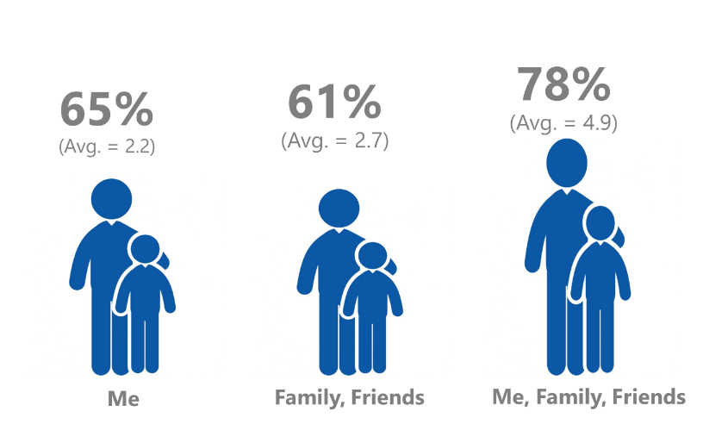
The Digital Civility Index (DCI) measures consumers’ lifetime exposure to online risks. Online risks were divided into four categories: Behavioral, Intrusive, Reputational and Sexual. Each category consisted of several individual risks. DCI scores were calculated by using the percentage of consumers who were exposed at some point in time to at least one of 17 different online risk(s). Lower scores equate to lower online risk exposure and a higher Digital Civility.

International DCI at 65%
Among the countries surveyed, 65% of adults and youth aged 13-17 reported having ever been exposed to an online risk averaging 2.2 risks per person. Online risk exposure rises 13-points when a person’s family and friends are included while the average number of risks more than doubles to 4.9.

Intrusive
- Unwanted contact (43%) was the main driver of Intrusive risks and had the highest incidence of any individual risk.
Behavioral
- Behavioral risks (39%) were the second most common occurring risk category. Over one in five had experienced Treated mean (22%) or Trolling (21%) and both were among the top five individual risks.
Sexual
- Three in ten consumers had experienced a Sexual risk (30%) led by Unwanted sexting (received or sent, 24%) and Sexual solicitation (15%).
Reputational
- Among Reputational risks, people were most likely to have encountered Doxing (12%) followed by damage to personal reputation (8%).

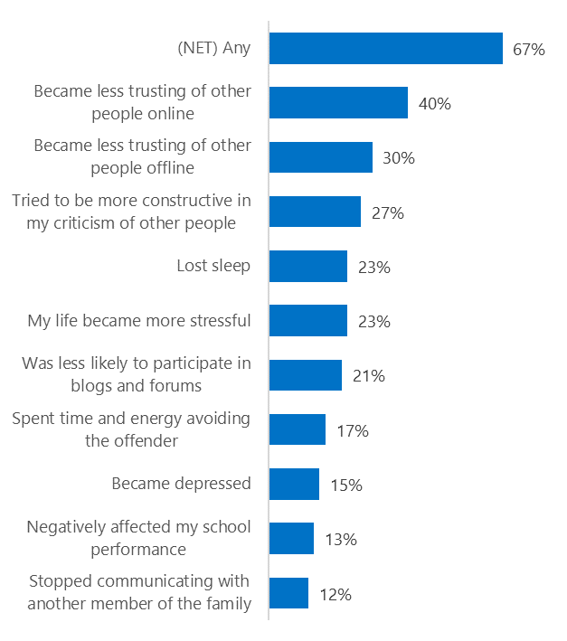
People became less trusting of others
Top 10 consequences
(Happened to me)

Two-thirds of consumers reported serious consequences from exposure to an online risk. Consequences were felt both in the online and offline worlds.
- The most likely consequence from online risk exposure was a loss of trust both online (40%) and offline (30%).
- Increased stress was a common outcome with people reporting my life became more stressful (23%), loss of sleep (23%) and became depressed (15%).
- Some people chose to withdraw by reducing the amount of participation in blogs and forums (21%) or stopping communications with a family member (12%).
- In an encouraging development, 27% tried to counterbalance negative outcomes by being more constructive in their criticism of others.

Online risks prompted strong concerns

62% of consumers said that they were extremely or very concerned about at least one online risk. People expressed a universal level of concern about all risks (~35%) as evidenced by the narrow range of scores across risks.
- Intrusive risks (56%) garnered the most concern closely followed by Behavioral (54%) and Reputational (54%).
- Reputational risks ranked near the top of people’s concerns despite the fact it was the least likely type of risk to have occurred.
- Doxing (44%) generated the highest level of concern followed by Damage to personal reputation (39%) and Terrorism recruiting (39%).

One in four experienced an online risk within the past month

- 26% of consumers experienced their most recent online risk within the past month.
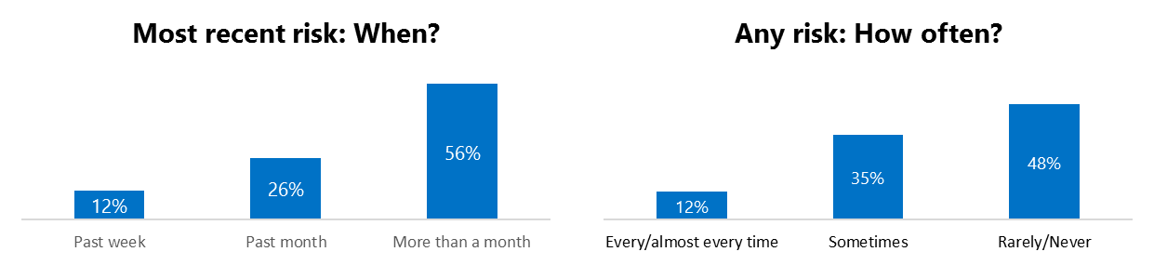
- 12% said the most recent online risk happened within the past week.
- 12% reported online risks happened every/almost every time.

Demographics

Age: Unsurprisingly, youth (ages 13-17) were found to have had a greater number of interactions online than adults (161, 127). Despite lower interaction levels, adults reported higher rates of online risk (67%, 62%) than youth. Youth said that their family and friends were much more likely to encounter risks than adults (69%, 54%). This suggested that youth were more willing to share their negative online experiences than adults.
Youth reported higher incidence of Behavioral risks (43%, 35%) and were more likely to have acted in response to a risk (84%, 77%) than adults.
Youth were less confident than adults in managing uncivil behavior, (50%, 45%) but were more knowledgeable about where to get help (48%, 26%) if needed.
Youth were more optimistic than adults about the outlook for civility (101, 123) and safety (95, 113) in the coming year.
Gender: Overall, males reported higher exposure to risks than females (67%, 62%) including all risk categories.
Females and males shared similar levels of concern (49%, 50%) and were equally likely to have acted in response to a risk (80%, 81%).
Males reported being more confident in managing risks than females (52%, 44%) and equally knowledgeable about where to seek help if needed (38%, 36%).

Past year interactions (% more minus % less x 100 +100) 2 Lower scores = felt more civil, safer (% worse - % better) x 100+100 3 Ibid.

